

**RAPE DETECTION AND PREVENTION SYSTEM USING IOT AND MACHINE LEARNING**

**NJOROGE ESTHER WAMBUI: 102008**

**SUPERVISOR: JAMES GIKERA**

An information system project proposal submitted to the faculty of information technology in partial fulfilment of the requirements of the award of a degree in Information and Computer science.

Date of submission: 23 June 2020

# Declaration

I declare that this project has not been submitted to any other university for the award of Bachelor of Science informatics degree

Admission Number: 102008

Signature …………… Date…………………

I certify that this work is being submitted for examination with my approval.

Supervisor name: James Gikera

Signature …………… Date………………

# Abstract

***Keywords: IOT, Machine Learning, Gender Based Violence.***

*Gender based violence is a recurrent predominant disorder in the society. There are actions that have been taken to suppress the situation but most of the incline to be unsuccessful.*

*Women tend to be easily targeted when they are alone or highly intoxicated. Thereafter, the victim may try to reach out to people or report the incident to the police, but the response time tends to be long and the reported case may not be treated with the seriousness it deserves due to factors like lack of evidence or unclear reports by the victim.*

*The aim of this project is to reduce response time by reaching out to a number of people at once, provide evidence of physical struggle and possibly prevent the abuse from occurring. The proposed system is in two segments IOT and Machine Learning. The IOT will include sensors to check the pulse rate, GSM and GPS modules that will facilitate communication with the selected contacts and the Machine Learning segment: creating a model that will be used to detect any signs of physical struggle and later a report will be generated with regards to the data collected. The report may be used for evidence.*

# Table of Contents

Declaration ii

Abstract iii

Table of Contents iv

Table of Figures v

Chapter 1: Introduction vii

1.1 Background vii

1.2 Problem Statement viii

1.3 Aim ix

1.3.1 Specific Objectives ix

1.3.2 Research questions ix

1.3 Justification ix

1.5 Scope and Limitation ix

Chapter 2: Literature Review xi

2.1 Introduction xi

2.2 Struggles experienced by victims during assault. xi

2.3 Technologies Used xi

2.3.1 IoT xi

2.3.2 Machine Learning xiii

2.4 Related Applications xiii

2.4.1 Athena xiii

2.4.2 Watch Over Me xiv

2.4.3 Safecity xv

2.4.4 React Mobile app xvi

2.4.5 Prevention Education xvii

2.4.6 SHE‐ Society Harnessing Equipment (IoT) xviii

2.5 Gaps in Existing Systems xix

2.6 Conceptual Diagram xix

References xx

# Table of Figures

Figure 1: GPS and GSM module xiii

Figure 2: Decision Boundary xiv

Figure 3: ATHENA xv

Figure 4: Watch Over Me xvi

Figure 5: Safecity xvii

Figure 6: React Mobile xviii

Figure 7: RPE xix

Figure 8: SHE xx

Figure 9: Conceptual diagram xx

# Chapter 1: Introduction

## Background

Gender based violence (GBV) is violence against women based on women’s inferior status in society which is considered to be a human rights violation. According to United Nations General Assembly in 1993, it takes forms such as Physical, psychological violence within the family, Trafficking in women and sexual abuse (Centre, 2014). It can be enacted by members of an army, terrorist organization or just a civilian.

According to data on Centre’s Website, it is indicated that since 2001 to date, the Centre has supported over 21,341 survivors of GBV, of whom 56% were women and 36% girls. In Kenya, 45% of women aged between 15 and 49 years have experienced either physical or sexual violence; One in five Kenyan women (21%) has experienced sexual violence. Most violence is perpetrated in familial relationships where the perpetrator is known to the victim, strangers account for only 6% of GBV in Kenya and most violence towards women is committed by an intimate partner, (Centre, 2014)

Community/Society- These are the people sharing common social, cultural, religious or ethnic belonging, it perpetuates existing family structure and power inequalities in the society. Family- This is the arena where physical abuses ( Minnesota Advocates for Human Rights, 2003).

In 2007, Kenya experienced post-election violence which brought a lot of disorder amongst its citizens. There were extremist groups or malicious individuals that would go from house to house, to torture the inhabitants; destroy their belongings and even to an extreme of sexual violence women. This was to impose punishment due to the ethnical classes and some would take advantage of the fact that measures were not being and also people lived in and hence the women couldn’t defend themselves.

Alcohol and drug abuse such as cocaine influence an individual’s tendency towards violence. The defendants of the 1991 National Criminal Victimization Survey alleged more than one fourth of violent criminal assailants were concluded to be drunk and less than 10% of these attackers were reported by victims to be under the influence of illicit drugs. Of these, more than half were reported to be under the influence of both alcohol and drugs (Parker & Auerhahn, 1998).

The numbers of unemployed youth are increasing to a point they would opt to commit crime in order to gain money for sustainability purposes. In the midst of all this, they commit sexual violence depending on the victim in this case being the women.

There have been cases of women being abducted and held hostage or sold to different countries lieu of payment. A different instance though rare in Kenya, the recruitment of women and promise them marriage and wealth, in such the women lured and fall prey to these false proposition. The ones behind this are highly capable of orchestrating sexual violence and sometimes end up killing the victims. (Bigio & Vogelstein, 2017)

## Problem Statement

There are many rape cases that reported to the police but only few of them get a hearing. When victims report these cases, they are mostly in a traumatised state, this makes then unfit to give accurate statements leading to improper recording of the report and remarking it as just an incident hence the investigations are likely not to be done. (Barr, 2019)

The rape few cases that make it to trial they are dealt in a manner contrary to the seriousness it requires. The of the survivors struggle to maintain their composure when confronted with their memories of the violence (Review, 2014). They are expected to show less emotions and give elaborate answers and descriptions when confronted with questions or objectivity to because these cases are normalised to sex. This discourages the victims from reporting the case in addition to it, stigmatisation from the society and sometimes the evidence isn’t considered enough.

There are certain traits that make one a rape-target, given that the women are highly likely to experience assault, women on their phone doing other activities while walking because they are off guard. There factors that favour the perpetrators, the use of a weapon to threaten the victim and the attack is most likely bound to happen very early in the morning or late in the night since there would be few people to witness.

Psychological Aggression is an aftermath of sexual violence and it takes exhibits itself in different ways such as, self-esteem, thus leading to anxiety, compliance, and passivity; (Jordan, et al., 2010). Emotional reactions like distrust and Sadness. Behavioural reactions like changes in eating or sleeping patterns, concerns about physical safety.

## 1.3 Aim

To develop an application that detects physical struggle and prevents women from being sexually assaulted.

### 1.3.1 Specific Objectives

1. To investigate the struggles experienced by victims during assault.
2. To review the existing solutions that prevent sexual violence from occurring.
3. To design and develop using the proposed technologies.
4. To test an application that implements the proposed system.

### 1.3.2 Research questions

1. What are the challenges faced by victims during the attack?
2. What are the existing solutions and the challenges they face?
3. How to develop a machine learning model?
4. How to test the system?

## Justification

The proposed system is meant to detect sexual violence using the Machine Learning model analysis that uses body movements to detect physical struggle, the victim able to use the data acquired and generated inform of a report, can be used as proof. The helps in case the victim decides to report the case to the police.

The IOT side of the system includes communication with enlisted contacts, the fact that more people are aware when the victim feels unsafe, increases the chance her getting help from people and the contingency that the police will be on time will be high.

Real time data analysis with renders the proposed system essential because data being generated automatically, this way persons with malicious motives don’t get to interfere with the data and less time is wasted given that the report can be sent immediately to the right personnel.

## 1.5 Scope and Limitation

Given that GVB is a broad subject, the proposed system aims to focus on Sexual violence.

Nairobi will be the point of focus given that it is a densely populated urban area and there tends to be a high rape cases There has of a record of 24.5 per cent of rape cases according to the Daily Nation. (Anon., 2019). With a population of 4,734,881 (Anon., n.d.), The women understudy will be 15 years and above since as stated before, 45% of women aged between 15 and 49 years have experienced either physical or sexual violence and it would be easier for them to operate the system with ease.

There is a high rate of unemployment and also drug and substance abuse by the youth this also increases the crime rate in the city.

Limitations: The victims are hard to approach given that they may be experiencing stigmatisation, Post S Traumatic disorder, social isolation or depression so they may shy away from being because they feel ashamed or are fearful of what may be said about them. The researchers as well might face some difficulties in obtaining sensitive information hence they need to be trained for such occurrences.

# Chapter 2: Literature Review

## 2.1 Introduction

This chapter discusses technologies used for the proposed systems which will be; IoT and Machine Learning, existing IOT applications that focus on Women security such as; Athena, Safecity, SHE, RPE and React Mobile alongside their shortcomings and conceptual diagram of the proposed system will also be illustrated.

## 2.2 Struggles experienced by victims during assault.

Fear overwhelms the victim like death or physical harm. The body responses of a person faced with danger would be the increased blood pressure, heart beat and stress levels increase and muscles tighten or tensed.

However, these reactions, in turn, may lead to behaviours which help avoid the victims avoid the stimuli that triggered the mental and physical reactions. (counselling center, n.d.)

## 2.3 Technologies Used

### 2.3.1 IoT

Given that sensors and actuators will be used, Arduino fits best with the proposed systems. An Arduino Pulse sensor will be used to check the heartbeat rate. The items included are; Arduino Uno Board and USB Cable, Jumper Wires, Pulse Sensor Arduino, 2 LEDs, Potentiometer 10Kand the Breadboard. The items will be connected using the breadboard having set different parameters, the board is connected to the computer using a USB cable. The Arduino code demo ought to be downloaded and unzipped into to the library before uploading the sample source code into the Arduino IDE.

Once the sample source code is downloaded, it is then opened it in the Arduino IDE. Choose the correct board and port. Then, upload your Code into your Arduino Uno Board. When you open your serial monitor, make sure you change your baud rate to 115200, it has to match to the baud rate stated in the sample source code.

After it’s done uploading, LED1 (red) should blink in synchronization with then heartbeat when you place your finger on the sensor. If you grip the sensor too hard, you will squeeze all the blood out of your fingertip and there will be no signal! If you hold it too lightly, you will invite noise from movement and ambient light. (mybotics, 2018)

The blood pressure Sensor goes the same steps of data processing as the Pulse sensor but the requirements may differ; Arduino UNO board w/USB cable, Arduino compatible LCD, Pressure Transducer (We used the Honeywell Differential Transducer 015PDAA5), Voltage-controlled valve, Air pump, Wires, Power Supply (±15V), Resistors (Four 100kΩ, One 1 kΩ), Capacitors (Two 1µF), Breadboard, Three-way splitter, Plastic Tubing, Blood Pressure Cuff and TL072 Op Amp. (LunesCuatro, 2019)

The electromyography (EMG) sensor measures small electrical signals generated by your muscles when you move them. The required item; circuit Chips, Cables and Electrodes, Power, Capacitors and Resistors. The type of EMG sensor being used is the Surface EMG (sEMG). This is how it works; The sensor is first placed in the arms; where it’s placed in the innervation zone of both tendons for better detection quality. Electrodes begin to detect electrical activity generated by muscle movement/contraction. Electrical activity detected is then displayed via the form of waves on the monitor. When unusual data is collected, the sensor is triggered.

The stress sensor. The components include; Arduino, a few resistors and capacitors, jumper wires, thermistor ,9V batteries, photo plethysmography (PPG) clips, , LTC1043 Switched Capacitor Building Blocks, LT1167 Instrumentation Amplifiers, LTC1064-2 8th order Butterworth filter, 2N3904 Bipolar Junction Transistor, two [Galvanic Skin Response finger clips](http://www.mindpeak.com/Neurofeedback-Device-GSR-clips.aspx) . The process is still the same, however, to get a reading, the thermistor used in a voltage divider circuit. As the resistance of the thermistor changes, so does the output voltage of the divider. This signal is low-pass filtered in order to get rid of noise. This filter can have a very low cut-off-frequency, since a person's breathing rate will be in the order of single-digit Hz. The respiration circuit also included a feedback amplifier and high pass filter. The temperature voltage signal is intensified with a gain of 100 and then a high pass filter was used to remove the Direct Current component of the signal. This signal is then put into one of the Arduino's analogue pins (ajdupree, 2014).

The GSM and GPS sensors are used to send messages to using a cell network and generate real time location data in form of longitude and latitude respectively, they are activated using the push button. One connected, the microcontroller monitors the GPS receiver and GSM modem to receive and transmit the data to the phone as text message.

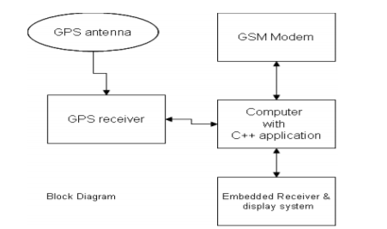

Figure 1: GPS and GSM module

Once all the data is collected, it is stored on a cloud-platform like AWS which will act as a source of data fir the Machine learning model.

### 2.3.2 Machine Learning

Using the data generated by the IoT device and Sexual Violence Datasets from sources like Safecity analysis will be performed. The data goes through Pre Processing where ‘cleaning’ will be performed like removing the empty spaces and performing extraction of relevant columns. The model will be formed based on the decision boundary technique and later Prediction will be done and a report will be generated based on the data, given that the Programming language used is Python.

Supervised learning is the technique used to map the data to the target variable (predicted output). Scikit-learn library will facilitate use packages like the numPY to enable data analysis. For the decision boundary technique to work the SVM algorithm is used, the inputs are divided into two classes, if results are above the decision boundary; it is match.

Figure 2: Decision Boundary

□ □ □

□ □ □

■ ■ ■ ■ ■

■ ■ ■ ■

■ ■

## 2.4 Related Applications

The existing systems include;

### 2.4.1 Athena

Athena is a black silicone pendant the size of a half-dollar and can be pinned to a purse, clothing, or even worn as a necklace. With a recessed button at the centre of the device to prevent accidental alerts, users can hold it for three seconds to trigger a loud alarm that will immediately notify friends and family of their current location, or alternatively, press it three times in quick succession to send a silent alert if you’re suspicious of being targeted. (Anon., 2017)

Silent ROAR is mode sends a message without an alarm and Alarm Mode, which sounds an alarm to emergency contacts. Athena also has 911 calling capabilities and via the ROAR Personal Safety app, users also have access to self-defence videos, general safety awareness tips, and the latest news related to gender equality.

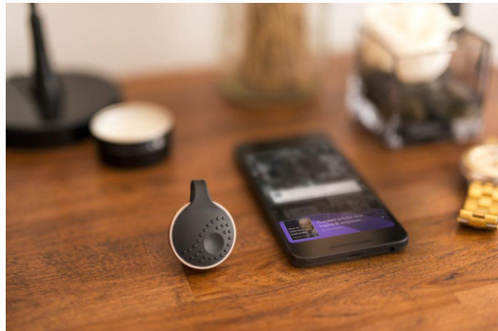

Figure 3: ATHENA

### 2.4.2 Watch Over Me

This is an application that allows the user to set a timer when traveling alone. When you’re in a situation where you don’t have time to make a call for help, just shake your phone and even if it’s locked the app turns on your phone’s alarm, video camera and sends an alert to your pre-set emergency contacts. The application warns you when you’re about to enter a high-[crime](https://www.psychologytoday.com/us/basics/law-and-crime) zone.”

You can choose to add updates in the form of texts, pictures, or video, and if you do not tap the “I’m Safe” button before the timer runs out, the enlisted contacts are sent to the location and any information you've uploaded. Because the app is activated based on inactivity, you’ll be taken care of even if you’re separated from your phone.

Figure 4: Watch Over Me

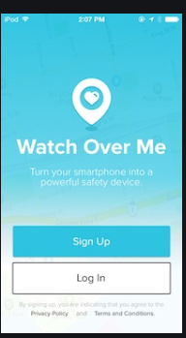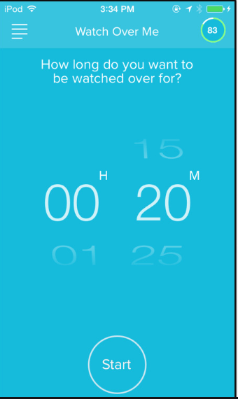

### 2.4.3 Safecity

This is an application that allows you to report harassment and feelings of threat on your location. There is a tracker function that allows you to track the enlisted contacts. Individuals share their personal stories of sexual harassment and abuse in public spaces, categorising them by place, time and type of harassment, other people using the software can see the regions with high cases and may avoid or be cautious of their location. Users can also upload photos and videos - any resource that can help them to share not only information, but also advice, and more importantly, support. (Bramley, 2015).

This application allows anonymity, the organisation that runs the application (The Red Dot Foundation) has been identifying location-based concentration patterns and trends where sexual violence crimes are committed. This data has been successfully used to engage over 400,000 citizens and official authorities including the police, municipal and transport authorities and community leaders across 15 cities.

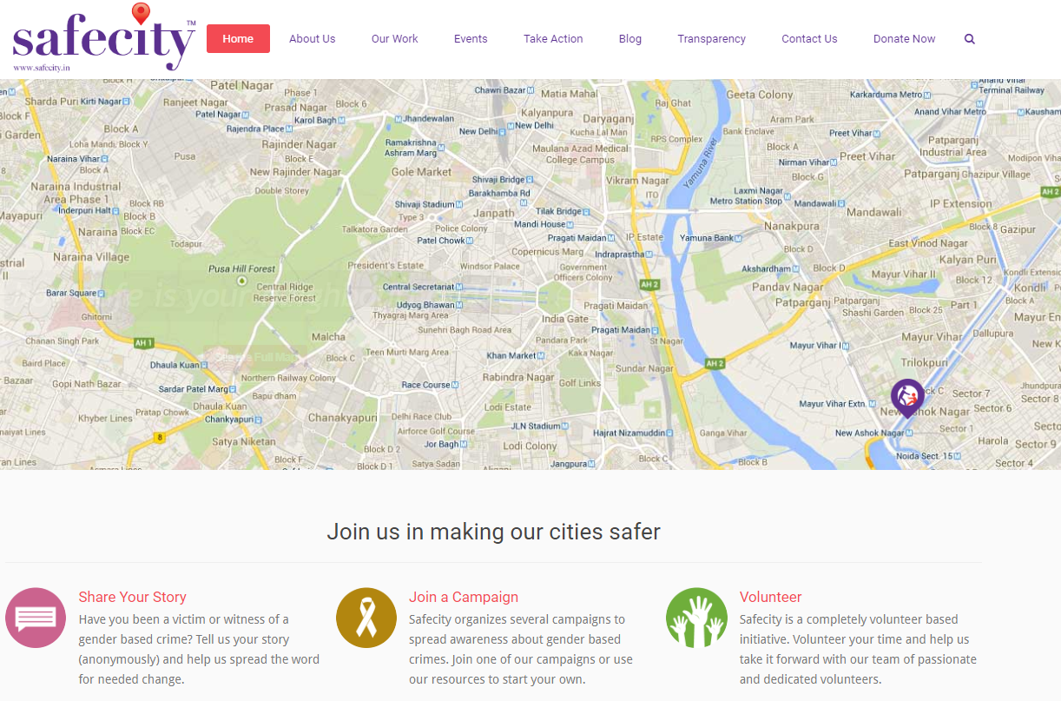

Figure 5: Safecity

### 2.4.4 React Mobile app

React Mobile offers both safety app and a panic button device that can be attached to clothing, car keys, wallets, or carried in hand. Once activated, a React Mobile dispatcher immediately provides emergency contacts with your profile information and GPS location. React Mobile also offers group packages, perfect for organizations and community groups looking to stay protected together.

The application allows the user to save contacts that would be contacted in case of an emergency. There are three options: ‘I’m fine’ when the feels safe. ‘Follow me’ is selected when the user feels the need share their location, the location is live until a different option is selected. The location is shared through text and email. The last option being ‘Help Me’, 911 would be automatically contacted but, the user has ten seconds to cancel the call in addition to, the selected contacts would have received a message stating that you are in danger.

However, the application has available concerns there are times when it can’t load this would be very risky when you the user does not feel safe.

Figure 6: React Mobile

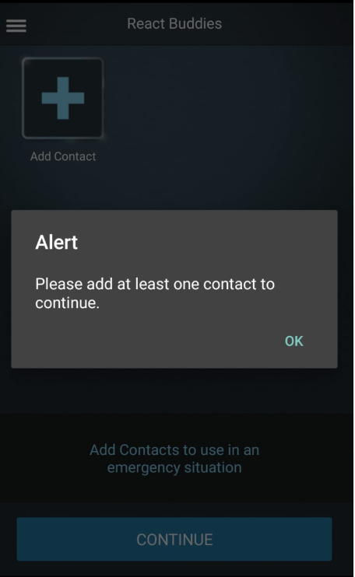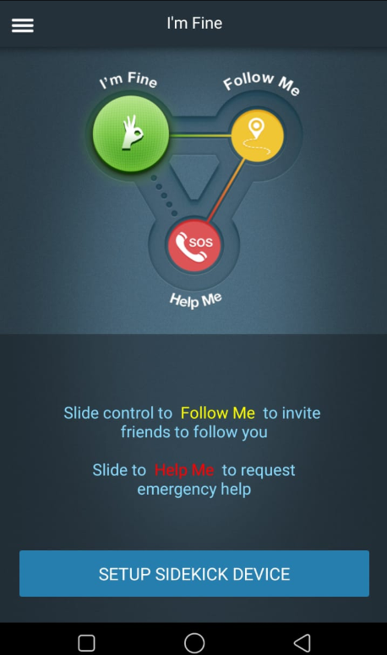

Figure 2. 5

### 2.4.5 Prevention Education

The education programs that have been that different adapted by different institutions to different types of age groups like teens and college students. The students’ normal curriculum won’t be interfered with, however, a lot of emphasis has been placed on eliciting student participation rather than presenting an entirely didactic program. Programs for older students may include: Setting clear personal boundaries. Confronting sex role stereotypes. Developing healthy attitudes toward emotional and sexual intimacy. Distinguishing between non-assertiveness, assertiveness, and aggressiveness.

The University of Michigan has a nationally known, full-fledged Sexual Assault Prevention and Awareness Centre that offers a wealth of services to the campus community. Their campus rape crisis centre provides peer education on rape prevention, organizes rape awareness weeks, and provides programs for men through the Men's Outreach Committee. (Joel Epstein & Langenbahn, 1994)

(Anon., 2019)

Figure 7: RPE

### 2.4.6 SHE‐ Society Harnessing Equipment (IoT)

It is an attire embedded with an IoT electronic device. The attire can distribute an electric shock to attackers strong enough to cause severe burns, protecting the victim from any of the electricity. The garment is fitted with a pressure sensor connected to an electric circuit with the capabilities of providing the electric shock when it is squeezed forcefully, and the system is placed in a bi-layer fabric, which ensures insulation to the victim (ZIKRIYA, et al., 2017)

The pressure measures or can differentiate actions like a squeeze, pinch and grab have been calibrated. The force applied on hugging cannot be quantified as a harmful action because does not fulfil the conditions for actuation of the device, and there is also a self-actuation switch where a woman can actuate it by herself when in unsafe environment." (Graham, 2013)

There are four flexible sensors in the fabric which can detect the position of your fingers, an accelerometer which tracks the movement of your arm, a joystick and four push buttons. The sensors and buttons can be configured anyway the wearer wants. It is linked to an interface app either on their computer or mobile device.

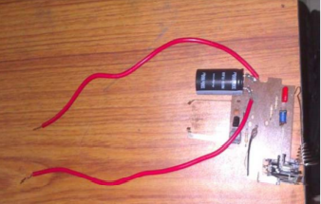

Figure 8: SHE

## 2.5 Gaps in Existing Systems

The measures that Athena and react Mobile take, may not prevent offenders from harming other people. They do not inform the users on area that have had previous cases of sexual violence and they tend to be expensive so only a few can access the device and if the perpetrator happens to get hold of the device the victim becomes hopeless. There is no existing Machine Learning Model, being integrated by IoT, that has been developed that is similar to the one being proposed. The devices consume a lot charge; a backup battery would be efficient.

## 2.6 Conceptual Diagram

The conceptual diagram gives visual representation of how the proposed system is going to work.

Figure 9: Conceptual diagram

Database

Database

IoT Integration

IoT Integration

ML model

ML model

Report

Report

Results

Results

Sensors

Sensors

# References

Minnesota Advocates for Human Rights, 2003. *What Is Gender-Based Violence?.* [Online]   
Available at: http://www.stopvaw.org

© National Sexual Violence Resource Cente, 2010. *The Impact of Sexual Violence.* [Online]   
Available at: www.nsvrc.org

ajdupree, 2014. *Instructables.* [Online]   
Available at: https://www.instructables.com/id/Arduino-Stress-Detector/  
[Accessed June 2020].

Anon., 2013. Justice and Gender-Based Violence. In: *Revue Internationale de Philosophie, Vol. 67, No. 265 (3), PHILOSOPHY AND VIOLENCE.* s.l.: Revue Internationale de Philosophie, pp. 259-275.

Anon., 2016. *TECHFASTER.* [Online]   
Available at: http://techfaster.com/stiletto-safety-device/

Anon., 2016. *Wangu Kanja Foundation.* [Online]   
Available at: https://wangukanjafoundation.org/

Anon., 2017. *10 Best Tech Devices to Prevent Rape.* [Online]   
Available at: https://www.psychologytoday.com/us/blog/the-body-blog/201704/10-best-tech-devices-prevent-rape

Anon., 2019. [Online]   
Available at: https://rpe.co.nz/

Anon., 2019. *Daily Nation.* [Online]   
Available at: https://www.nation.co.ke/news/Kilifi-leads-in-Kenya-incidence-of-rape/1056-5369726-28pfhfz/index.html

Anon., n.d. [Online]   
Available at: https://worldpopulationreview.com/world-cities/nairobi-population/

Anon., n.d. *LOYOLA University Maryland.* [Online]   
Available at: https://www.loyola.edu/department/counseling-center/students/concerns/sexual-assault/reactions  
[Accessed 21 June 2020].

Barr, C., 2019. *Thousands of rape reports inaccurately recorded by police.* [Online]   
Available at: https://www.theguardian.com/society/2019/sep/19/thousands-of-reports-inaccurately-recorded-by-police

Bigio, J. & Vogelstein, R., 2017. *Countering Sexual Violence in Conflict,* s.l.: Council on Foreign Relations.

Bramley, E. V., 2015. *The Guardian.* [Online]   
Available at: https://www.theguardian.com/cities/2015/aug/13/can-the-safecity-app-make-delhi-safer-for-women#:~:text=The%20Safecity%20app%20lets%20women,happened%20and%20when%20it%20happened%E2%80%9D.  
[Accessed 14 June 2020].

Centre, N. C. R., 2014. *GENDER BASED VIOLENCE IN KENYA,* Nairobi: s.n.

Graham, F., 2013. *BBC.* [Online]   
Available at: https://www.bbc.com/news/business-22110443  
[Accessed 14 June 2020].

Joel Epstein, E. & Langenbahn, S., 1994. *The Criminal Justice and Community Response to Rape ,* s.l.: National Institute of Justice. .

Jordan, C. E., Campbell, R. & Follingstad, D., 2010. Violence and Women’s Mental Health: The Impact of Physical, Sexual, and Psychological Aggression. july, p. 607–628.

LunesCuatro, 2019. *Instructables.* [Online]   
Available at: https://www.instructables.com/id/Blood-Pressure-Monitor/  
[Accessed June 2020].

Manzatto, A. A., 2019. *Medium.* [Online]   
Available at: https://medium.com/omdena/is-this-place-safe-274fc31c02c6  
[Accessed 19 June 2020].

mybotics, 2018. *Instructables circuits.* [Online]   
Available at: https://www.instructables.com/id/Pulse-Sensor-With-Arduino-Tutorial/  
[Accessed june 2020].

Parker, R. N. & Auerhahn, K., 1998. *ALCOHOL, DRUGS, AND VIOLENCE,* California: s.n.

Review, A., 2014. Sexual Violence and Its Discontents. 18 July, p. 139–154.

ZIKRIYA, M., G, P. M., MATH, S. R. & TANKASALI, S., 2017. *SMART GADGET FOR WOMEN SAFETY USING IoT,* BAGALKOT: BASAVESHWARA ENGINEERING COLLEGE.